Name: ______________________________ Date: ___________

Directions: As you read, note what mind work the text is signaling you to do. Stop and jot down a quick sketch of an important scene, list your ideas about one part of your book, record any questions you have, or write down your predictions.
Circle one:  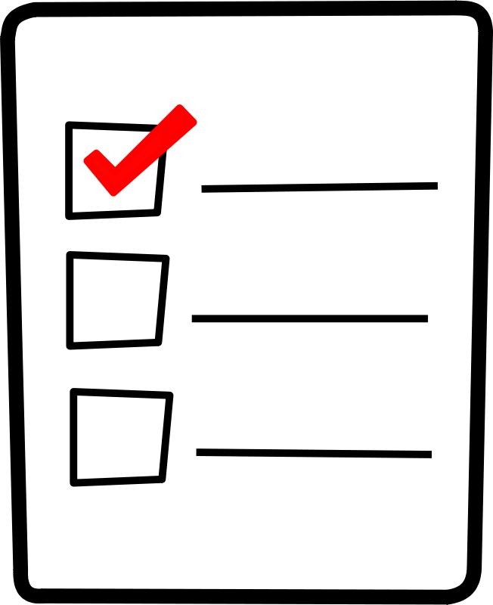 | Circle one:
Circle one: | Circle one:
Circle one: | Circle one:
Circle one: | Circle one:

